EDF5035 - Health and physical education in the primary years
Assessment task 2: Planning resource
Namrata Adsul

UNIT TITLE:  I like to move it! | FOCUS AREA/S:  rhythmic and expressive movement activities (RE)  mental health and well-being (MH) |  |  |  | LEVEL /YEAR:  Level 3-4 | SEQUENCE & LENGTH:  Weeks 1-10 (10 hours)  School Term
OVERVIEW OF THE UNIT:
‘I like to move it!’ is a movement-based unit plan created to promote mental well-being through dance movements. We believe it is important for children to understand the positive effects of movement for physical and mental wellbeing and that it can be achieved through simple enjoyable activities like dance. This is especially critical in today’s world when issues related to mental health are on the rise. In addition, the Australian Professional Standards for Teachers (APST) mandates teachers to support students’ well-being working within school and curriculum requirements.
The ‘Strengths-based approach’ and ‘Valuing movement’ Health and Physical Education propositions are utilised here to ensure the potential of movement for personal health is understood in a positive manner while they learn to use their strengths to build capabilities. In this process, students explore and apply dance movement concepts related to body, space, time and effort.
This unit is an integrated with a whole-school approach for visible well-being. Students come from diverse linguistic, cultural and intellectual backgrounds. Physical abilities range from developing to proficient.
CONTENT DESCRIPTIONS: |  |  | ELABORATIONS:
MOVEMENT AND PHYSICAL ACTIVITY – UNDERSTANDING THE MOVEMENT
Examine the benefits of physical activity and physical fitness to health and wellbeing (VCHPEM100). |  | - examining the benefits of regular physical activity, including the influence on sleep, concentration and fitness (LLPA, HBPA, MH)  - collecting, recording and organising information to investigate which physical activities people engage in to maintain health, wellbeing and fitness (HBPA)
Combine the elements of effort, space, time, objects and people when performing movement sequences (VCHPEM101). |  | - demonstrating acceleration and deceleration of movement in physical activities (FMS, RE, AP)  - discussing and demonstrating different levels, movement pathways, and use of space and flow in movement sequences (RE)  - using the body to demonstrate an understanding of symmetry, shapes and angles when performing movement skills, balances or movement sequences (RE, FMS)
MOVEMENT AND PHYSICAL ACTIVITY – LEARNING THROUGH MOVEMENT
Adopt inclusive practices when participating in physical activities (VCHPEM102). |  | - using cooperative skills to complete a movement task, such as a partner balance, partner passing strategy or team strategy (RE, RS, AP, FMS, CA)  - working cooperatively with team members to maintain possession in a game by passing to other players and listening to team-mates (AP, RS)  - modifying physical activities to ensure that everyone is included, such as changing equipment, rules or playing space (RS, RE, FMS, AP)
PERSONAL, SOCIAL AND COMMUNITY HEALTH – BEING HEALTHY, SAFE AND ACTIVE
Identify and practise strategies to promote health, safety and wellbeing (VCHPEP091). |  | - proposing changes they can make to their daily routines to reduce sedentary behaviour and increase physical activity levels (MH, HBPA)
ACHIEVEMENT STANDARD/S:
By the end of Level 4,
- students investigate how emotional responses vary and understand how to interact positively with others in different situations including in physical activities.
- students understand the benefits of being fit and physically active and how these can promote health and wellbeing.
- apply strategies for working cooperatively and apply rules fairly.
- select and demonstrate strategies that help them stay safe, healthy and active at home, at school and in the community.
- refine fundamental movement skills and apply movement concepts and strategies in different physical activities and to solve movement challenges.
- create and perform movement sequences using fundamental movement skills and the elements of movement.
HPE PROPOSITIONS:
Strengths-based approach –
The unit focuses on using this approach to support students develop the knowledge, understanding and skills they require to make healthy, safe and active choices that will enhance their own health and wellbeing. They learn to use their strengths and identify resources (such as dance) that can be nurtured to improve their own health, wellbeing, movement competence and participation in physical activity.
Value movement –
The unit focuses explicitly on developing movement skills and concepts needed in physical activities with competence and confidence through dance. The knowledge, understanding, skills and dispositions students develop during the course of this unit encourage ongoing participation across their lifespan and in turn lead to positive health outcomes. Students are also given an opportunity to enhance a range of personal and social skills and behaviours that contribute to health and wellbeing.
LEARNING AREA INTEGRATION:
THE ARTS - DANCE
Explore and Express Ideas
Use safe dance practice, fundamental locomotor and non-locomotor movements, body parts, bases and zones to explore, improvise and structure movement ideas for dance (VCADAE021)
- trialling ways of safely using the whole body and different body parts, bases and zones to communicate ideas, experiences and feelings, for example, making a rounded shape to explore ideas about enclosed spaces.
- exploring options for creating and extending movements, alone and then with a partner, for example, forming and changing shapes within space.
- using questions to explore ways of using forms and elements, for example, dancers consider how they can communicate an emotion or idea, how a shape can be varied, how two shapes can be combined.
- using stimulus materials to explore ideas for dance, for example, using percussion instruments or body percussion to explore how movements can be varied by performing them at different speeds, or identifying patterns in images and recreating the ideas through movement.
Dance Practises
Use choreographic devices to select and organise movement ideas and create and practise dance sequences (VCADAD022)
- practising fundamental movements such as walking, running, marching, galloping, skipping, crawling, bending, stretching, twisting and turning, focusing on technical skills of body control, posture, strength, balance and coordination
- devising a range of body shapes and travelling movements suggested by action words focusing on the dynamic qualities, for example, rising, jumping, stopping, falling, opening, closing and then use the devices of repetition and contrast to form dance sequences
- using questions as part of the dance-making process, for example, asking how ideas are communicated in this dance, how they are varying speeds, levels, directions?
- exploring movement possibilities and making choices about ways of communicating emotions or observations about the texture of an object, for example, eating something sticky
- making decisions about how a short dance will begin and end, refining and evaluating options through feedback, practice and repetition
Present and perform
Use simple technical and expressive skills when presenting dance that communicates ideas about themselves and their world to an audience(VCADAP023)
- rehearsing learned dance sequences in the performance space, discussing feedback and making changes to enhance communication with the audience
- combining movement and the use of props such as scarves when presenting dance
- performing a dance they have created to the class focusing on using appropriate facial expressions and maintaining safe dance practices
- using questions to interpret dance they view, for example, what did this dance make them think about and why? what shapes can they see in the dance?, how are the movements combined?
GENERAL CAPABILITIES:
Personal and Social Capability  Self-awareness  Recognise personal qualities and achievements  Social awareness  Understand relationships  Self-management  Work independently and show initiative  Express emotions appropriately  Become confident, resilient and adaptable  Social management  Make decisions  Critical and Creative Thinking  Inquiring – identifying, exploring and organising information and ideas  Organise and process information  Identify and clarify information and ideas  Generating ideas, possibilities and actions  Seek solutions and put ideas into action  Consider alternatives  Literacy  Comprehending texts through listening, reading and viewing  Navigate, read and view learning area texts  Listen and respond to learning area texts  Interpret and analyse learning area texts  Comprehend texts  Composing texts through speaking, writing and creating  Use language to interact with others  Compose spoken, written, visual and multimodal learning area texts |  |  |  | Word Knowledge  Understand learning area vocabulary  Ethical Understanding  Exploring values, rights and responsibilities  Examine values  Consider points of view  Understanding ethical concepts and issues  Recognise ethical concepts  Numeracy  Recognise and use patterns and relationships  Intercultural Understanding  Interacting and empathising with others  Information and Communication Technology (ICT) Capability  Students use ICT as key tools for communicating, collaborating, creating content, seeking help, accessing information and analysing performance in the health and physical education field  They use a range of ICT to analyse, measure and enhance movement performances and to access and critically evaluate health information, products and services.  They also use ICT to develop personalised plans for nutrition, physical activity participation and wellbeing.
EVIDENCE OF LEARNING – ASSESSMENT + REPORTING
Assessments in this unit include structured observations, Reflection tickets, posters, dance performance, self-assessment, informal discussions and reflections.

Key knowledge developed through the unit:
By the end of the unit, students are able to examine the benefits of physical activity and physical fitness to health and well-being. They collect, record and organise information to investigate which physical activities people engage in to maintain health, wellbeing and fitness.
Key skills developed throughout the unit:
It is the responsibility of the teachers to ensure students in their formative years, particularly in Years Prep to 3 develop basic physical education skills, which includes the development of essential fundamental skills related to dance such as dodge, run, vertical jump and leap. Hence, this unit includes exploration and development of these skills through various warm-up and main body activities.
By the end of the unit, students learn to combine the elements of effort, space, time, objects and people when performing movement sequences. They demonstrate acceleration and deceleration of movement in physical activities, discuss and demonstrate differing levels, movement pathways and use of space and flow in movement sequences. Laban’s movement framework’s four aspects help students see the totality of human movement in relation to dance movements (2007). Students also understand the benefits of adopting inclusive practices when participating in physical activities.

These are done through the following:
- Informal observations in the Exploration phase are used as a diagnostic assessment tool to modify activities in order to cater to students’ learning needs. The same are compared to the completed rubric at the end of the term.
- Due to the comprehensive nature of the unit, students will be marked against a rubric (see Appendix) throughout the term when various concepts are covered over the weeks. For example, Criteria 1 is assessed in week 3. These are done through informal observations by the teacher.
- Student learning is monitored as they are provided with constructive feedback on an ongoing basis during activities on their strengths and weaknesses.
Students perform a self-assessment on the last day of the term. They are asked to critically evaluate their own progress and skill development. This is to ensure they can identify gaps in their understanding and capabilities to improve their performance.
Unit phase | What will students learn (What) | Description of learning activities (How) | Resources
1 | By the end of the lesson, students will be able to:  demonstrate changes in speed, direction and level of movement in response to changes in music tempo  identify positive feelings, they experience when participating in physical activities | Students reflect on their feelings on reflective ticket.  Warm up (15 min)  Circular Tag: Students tag the person next to them while moving clockwise in a circle; while, the teacher directs students to perform fundamental movements (Appendix A).  Body (30 min)  The space is divided into four sections signifying certain body positions. Students explore use of space, time and energy, while moving to music with different tempo and rhythms.  Conclusion (15 mins)  Students identify positive feelings experienced by movement activities, through reflection ticket, and whole-class discussion. | - Lesson Plan (Appendix A)  - Exit Ticket (Appendix B)  - Chalks  - Texters  - Lead Pencils  - Music:  I Like to Move It  https://www.youtube.com/watch?v=hdcTmpvDO0I  Enigma - Le Roi Est Mort, Vive Le Roi!  https://www.youtube.com/watch?v=unSZj3jv7Vk  Thunderstorm in the City at Night  https://www.youtube.com/watch?v=kLau-noe_Pk  Carnival Of Folk Dancing  https://www.youtube.com/watch?v=NoJT4WBMeyo  Four Seasons ~ Vivaldi  https://www.youtube.com/watch?v=GRxofEmo3HA
2 | By the end of the lesson, students will be able to:  create movement sequences in response to music  modify physical activities to ensure that everyone is included | Students reflect on their feelings on reflective ticket.  Warm up (15 min)  Mirror Mirror: In pairs, students to move to the meaning represented by music. One student performs the movement, and the other copies it. Students alternate being the mirror of their partner.  Body (30 min)  Students brain-storm about movements related to different seasons though prompts (Appendix C).  In small groups, students form a movement sequence of at least 4 movements to represent their assigned season and music.  The class guess and discusses the meaning of each performance.  The teacher will brief about equity considerations. Ask students to adjust their choreography to accommodate differing abilities. For instance, someone may not be able to perform low crouching movements; henceforth, the students could change the level in which  those movements are performed.  Conclusion (15 mins)  Students reflect on experience of inclusive collaborating through reflection ticket, and whole-class discussion. Use promots:  Did you have to change certain movements that you could do but the other person could not do? How did that make you feel? | - Exit Ticket (Appendix B)  - Activity 2 Prompts (Appendix C)  - Texters  - Lead Pencils  - Music  I Like to Move It  https://www.youtube.com/watch?v=hdcTmpvDO0I  Enigma - Le Roi Est Mort, Vive Le Roi!  https://www.youtube.com/watch?v=unSZj3jv7Vk  Thunderstorm in the City at Night  https://www.youtube.com/watch?v=kLau-noe_Pk  Carnival Of Folk Dancing  https://www.youtube.com/watch?v=NoJT4WBMeyo  Four Seasons ~ Vivaldi  https://www.youtube.com/watch?v=GRxofEmo3HA
3 | By the end of the lesson, students will be able to:  discuss and demonstrate use of the body in movement | Students reflect on their feelings on reflective ticket.  Warm up (15 min)  Frogs and Lily Pads: Students move freely, and when the music stops they will jump in the Lily pads (Hula-hoop) and make shape with their bodies to represent objects or animals or activities. The teacher will ask students to jump on lily-pad in group of two, or three students to form a collaborative shape.  Body (30min)  Statues and speed: Students form a wide circle. On the Drum’s sound, one student moves in the circle to start formation of a shape. Then, one by one, other students join in to form a whole-class shape with their bodies. Repeat the activity by asking students to perform the activity more quickly than before (Appendix D).  At different points throughout the activity, conduct explicit teaching on use of body while performing movement.  Conclusion (15 mins)  Explicit Teaching: Students reflect on their use of body while moving, through reflection ticket, and whole-class discussion. | - Exit Ticket (Appendix B)  - Texters  - Lead Pencils  - Drum  - Hula-hoop  - Statutes and Speed (Appendix D)
4 | By the end of the lesson, students will be able to:  discuss and demonstrate use of space in movement | Students reflect on their feelings on reflective ticket.  Warm up (15 min)  Octopus: Students tag each other while moving through the space divided into three parts i.e. smooth, sharp, fast movements. Students can rescue ‘seaweed’ (tagged students).  Body (30min)  Follow the leader: Students form groups of 5 or 6. The leader keeps changing after every 15 to 20 seconds on teacher’s instruction. initially, dancers will be shown flashcards: walk, stop, run, change direction, touch the ceiling, touch the floor, jump, roll. Later, ask students to visit every space while moving in response to music.  At different points throughout the activity, conduct explicit teaching on key aspects of using space while performing movement. For instance, discuss low, middle, high level movements.  Conclusion (15 mins)  Students reflect on their use of space while moving, through reflection ticket, and whole-class discussion. | - Exit Ticket (Appendix B)  - Texters  - Lead Pencils  - Music  I Like to Move It  https://www.youtube.com/watch?v=hdcTmpvDO0I  Enigma - Le Roi Est Mort, Vive Le Roi!  https://www.youtube.com/watch?v=unSZj3jv7Vk  Thunderstorm in the City at Night  https://www.youtube.com/watch?v=kLau-noe_Pk  Carnival Of Folk Dancing  https://www.youtube.com/watch?v=NoJT4WBMeyo  Four Seasons ~ Vivaldi  https://www.youtube.com/watch?v=GRxofEmo3HA
5 | By the end of the lesson,  students will be able to:  discuss and demonstrate acceleration and deceleration of movement in physical activities | Students reflect on their feelings on reflective ticket  Warm up (15 min)  Reflect on their feelings on reflective ticket.  Dance tag: Randomly choose 3 taggers. Once tagged, students’ start performing a movement in place. Other students can free their peers by copying their peer’s movement for 5 seconds.  Body (30min)  Show video of Fortnight Dances. Students dance along the video.  Students are divided into groups of three to perform any dance movements of their choice through prompts to perform:  · as quickly as possible.  · as slowly as possible.  · as if you were late for a train.  · as if you have two heavy suitcases (Appendix E)  Ask students to improvise to make creative prompts.  Debrief about Safety.  Intentional Teaching: At different points in the activity, the teacher discusses key ideas related to acceleration and deceleration of movements according to different situations and how these affect movement. For example, ‘which movements are fast and which ones are slow?’  Conclusion (15 mins)  Students reflect on their use of time and effort while moving, through reflection ticket, and whole-class discussion. | - Exit Ticket (Appendix B)  - Prompts (Appendix E)  - Texters  - Lead Pencils  - Dance Tag  https://docs.wixstatic.com/ugd/ff464b_fc298cf7b8d74888a2309ec33d7214e9.pdf  - Fortnight Video  https://www.youtube.com/watch?v=bcaDTmAC8TM  - Flashcards of Movements  - Music  I Like to Move It  https://www.youtube.com/watch?v=hdcTmpvDO0I  Enigma - Le Roi Est Mort, Vive Le Roi!  https://www.youtube.com/watch?v=unSZj3jv7Vk  Thunderstorm in the City at Night  https://www.youtube.com/watch?v=kLau-noe_Pk  Carnival Of Folk Dancing  https://www.youtube.com/watch?v=NoJT4WBMeyo  Four Seasons ~ Vivaldi  https://www.youtube.com/watch?v=GRxofEmo3HA
6 | By the end of the lesson, students will be able to:  adopt inclusive practices when participating in physical activities  demonstrate cooperative skills as they work cooperatively with team members | Students reflect on their feelings on reflective ticket.  Warm up (15 min)  Protect the Kingdom (see Appendix F): Each team has to protect their spot by dodging the ball and aiming the ball at others’ kingdoms to win the game.  Body (30min)  Students stay in the same group for this team-building activity. They are given equal amounts of materials, like pipe cleaners, blocks, dried spaghetti, 1 metre of sticky tape and marshmallows. The challenge is to construct or build the tallest, structurally-sound castle? Which team can build the tallest castle for their kingdom?  Before students start, teacher explicitly models concepts of working in teams such as listening to others’ ideas, contributing, accepting differences.  Conclusion (15 mins)  Students reflect on ways in which they worked collaboratively by sharing responsibilities, through reflection ticket, and whole-class discussion (see Appendix F).  Teacher makes explicit connections to the final dance sequence activity. | - Exit Ticket (Appendix B)  - Activity 6 (see Appendix F)  - Texters  - Lead Pencils  - Music  - Protect the Kingdom game: cones, sashes, bowling pins.  - Team building activity materials
7 | By the end of the lesson, students will be able to:  Investigate and examine the benefits and way of increasing physical activity and physical fitness to health and wellbeing | Warm up (15 min)  A picture storybook (chosen from the two options mentioned in ‘Resources’) is read to children introducing them to mental health through relatable stories.  Body (30mins)  Students watch the video (chosen from the two options mentioned in ‘Resources’). The animation would be used a prompt for Stop and Share about whole class discussion about mental health.  Activity A  Discuss what students think makes up a good life.  List various items on the board such as food, money, clothes, health, exercise, etc. Discuss what students think the term “balance” means. Ask the class for suggestions about what “balance” means and then refer to a dictionary definition.  Lead a discussion explaining why a balanced life is better than one that has too much of one thing or not enough of another.  Activity B  Introduce the worksheet Balance Scorecard (also displayed on interactive whiteboard).  Discuss how having a balanced lifestyle that includes physical activity can benefit our social skills and increase our mental wellbeing. Here, children investigate the types of physical activity that children can be involved in and list them.  Activity C  Children identify the benefits of physical activity – healthy bones, heart, muscles and self by conducting research on iPads.  Investigate the benefits of physical activity to emotional health – good self-esteem, psychological wellbeing and reduction in feelings of depression and anxiety. They refer to Reflection tickets to make connections between what they have been doing and how they felt while moving.  Conclusion (15mins)  Students post on Padlet (www.Padlet.com) regarding new knowledge they have acquired form the class They post audio, pictures, drawings, video, text, or multi-media format. Conduct a whole-class discussion. | - Texters  - Lead Pencils  - ‘Alexander and the Terrible, Horrible, No Good, Very Bad Day’ by  Judith Viorst.  - ‘When Monkey Lost His Smile’ by Stephanie Margolese.  - Scorecard https://www.healthyactivekids.com.au/wp-content/uploads/2014/01/U3L8R1-Balance-Scorecard.pdf  - iPads for research/ investigation.  - Charts  - Video:  Talking Mental Health  https://www.youtube.com/watch?v=oz1S66_pYTw - with subtitles OR https://www.youtube.com/watch?v=754__xBsak4  .
8 | By the end of the lesson, students will be able to:  discuss and demonstrate different levels, movement pathways, and use of space and flow in movement sequences | Students reflect on their feelings on reflective ticket.  Warm up (15min)  Pass the movement: Students form a circle. A student does a movement, the student next to him/her copies the movement and adds his/her own movement; then, the third child does the movement performed by the first person, second person and adds his own movement. If somebody forgets, they sit down but can enter the game again if they help someone else remember the move.  Body (30min)  Through a KWL Chart and post-its, conduct a class-discussion on creating movement sequences.  Live dance performance by children from the ‘Dance club’ or a parent volunteer, who is a dancer.  Explicit Teaching: Reflective discussion with an emphasis on how various steps or movements are combined together in a sequence. Volunteers help through demonstrations.  Movement Math: Students are given a worksheet with an addition sum of movements to help with ‘counts’ of the movement sequence.  Students use the worksheet to analyse the dance performance, and improvise the use of space, time, effort and body.  In pairs, groups or by themselves, students will practice the improvised movement sequence.  Conclusion (15mins)  Students reflect through reflection ticket prompt:  - Did changing the space, time, energy and actions of a known dance sequence change the intended look or meaning of the dance? How?  Teacher Introduces the final dance performance task (See Appendix H). | - Exit Ticket (Appendix B)  - Texters  - Lead Pencils  - Movement math worksheet (Appendix G)  - Final dance performance task instructions (Appendix H)  - Music  I Like to Move It  https://www.youtube.com/watch?v=hdcTmpvDO0I  Enigma - Le Roi Est Mort, Vive Le Roi!  https://www.youtube.com/watch?v=unSZj3jv7Vk  Thunderstorm in the City at Night  https://www.youtube.com/watch?v=kLau-noe_Pk  Carnival Of Folk Dancing  https://www.youtube.com/watch?v=NoJT4WBMeyo  Four Seasons ~ Vivaldi  https://www.youtube.com/watch?v=GRxofEmo3HA
9 | By the end of the lesson, students will be able to:  practice combining the elements of effort, space, time, objects and people when performing movement sequences | Scaffolding Framework  Step 1 (10 minutes)  Select song. Finalise one to two minutes of the song for dance performance.  Step 2 (20 minutes)  Students are given time to create their dance sequence. Teacher provides questions to help think about the sequence – (see Appendix I).  Next, they use ‘Elements of movement menu’ to help select and create dance sequence involving body, space, time and effort. Teacher explains and models first. Individual support provided to groups if needed.  Step 3 (15 minutes)  Practice the dance sequence to music.  Conclusion (15 mins)  Students reflect on challenges and learning from the lesson through reflection ticket, and whole-class discussion. | - Exit Ticket (Appendix B)  - Texters  - Lead Pencils  - Elements of movement menu - http://www.prodivame.com/uploads/6/6/3/3/6633752/creating_movement_using_the_elements_of_dance.pdf  - iPads for selecting and playing music
10 | By the end of the lesson, students will be able to:  perform movement sequences and demonstrate combination of movement elements (effort, space, and time) | Dance performance  Each group performance for five minutes, followed by a three-minute discussion on interesting aspects of the performance.  The students should also be encouraged to be attentive to and supportive of the performers  Teacher encourage students to:  • be involved within a supportive environment  • value diversity of ability, opinion and experience  • support one another’s efforts  • become empowered to represent their ideas and feelings through kinaesthetic forms of expression.  .Stress  Reflection: Students reflect on their performance with the help of the Dance Assessment Rubric. | - Dance Assessment Rubric  http://www.prodivame.com/uploads/6/6/3/3/6633752/creative_dance_journal_-_assessment.pdf
Students learn to draw on existing strengths and resources to promote action and choice through the inquiry-based activity. In this process, they build skills to promote confidence and capacity to take action to be physically and mentally healthy.
Appendix A
Activity 1: Lesson Plan
Warm up (15 min): Circular Tag
1. First, students on a circle made by chalk.
· For safety precautions, make circle as big as possible.
· Students stand at arms’ length with students at the sides.
2. Then, all students walk clockwise and perform fundamental movement skills in response to teacher’s directions.
· Instruct students to run, walk, gallop, change direction, walk backwards, stop, hop, skip, leap, run, jump
· Students must maintain the distance between students and size of the circle throughout the improvisation
· Continue until students are comfortable with maintaining the flow of moving as a community
3. Ask students to tag the person in front of them without getting tagged themselves.
· Students raise their arms when tagged and can’t tag anyone else
· Keep playing until all the students’ arms are in the air, or 15 minutes are over.
Body (30 mins)
1. The gym/space is divided into four parts that specifies body positions to perform movements:
· Bottoms touch the ground
· Knees touch the ground
· Feet touch the ground
· Backs or abdomens touch the ground
2. Students move to music with different tempo and rhythms.
· Ask students to move creatively according to their comfort and abilities.
3. Between songs, ask students to notice and share observations on various ways (use of space, time and energy) in which their body responds to the mood and pace of the song.
· Did my movements cover a lot of space or did I stay on the spot? Why, why not?
· Did my movements happen over a long amount of time or did they happen quickly? Why, why not?
· Were my movements strong and high in energy or were they gentle or continuous? Why, why not?

Conclusion (15 mins)
1. Exit Ticket/Reflection Sheet: Students respond Individually by drawing or using words.
2. Stop and Share: Students talk with the person next to them.
· How does the movement make me think and feel?
· Which movements did I enjoy the most? Why?
Whole-group discussion on positive feelings experienced by movement activities.

Appendix B
Exit Ticket
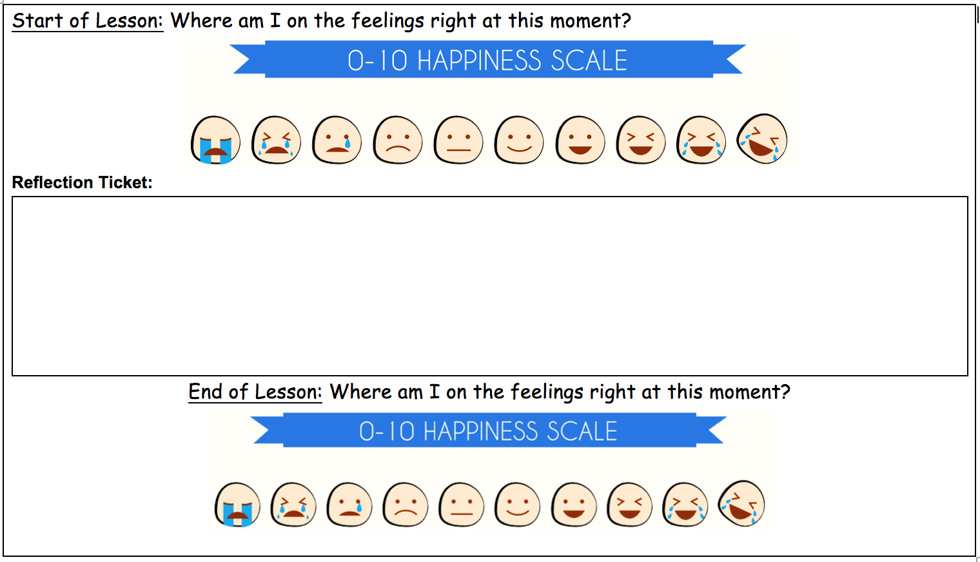

Appendix C
Activity 2 Prompts
Teacher can model actions.
For example:
summer — melting slowly,
autumn — walking on dry, fallen leaves,
winter — shivering on the spot,
spring — running in a circle.

Some prompts include:
Summer- You feel exhausted from the heat — your hands, feet, torso, neck and head feel as though they are melting to the floor.
Autumn- You start to feel your strength return as the weather cools — stretch your arms high over your head, reach down to your toes, curl and uncurl your fingers and toes.
Winter- You begin to feel cold — curl up in a small ball to keep warm, uncurl and run on the spot to keep warm, make your arms and legs shiver.
Spring- You don’t feel cold anymore — skip in a circle around the room, run on the spot lifting your knees to your chest, jump from one foot to another moving throughout the space.

Some questions:
  - What colours, feelings, temperatures and emotions do you associate with the various seasons?
  - What sorts of movements did you create and perform when you explored your ideas about the seasons?
  - Which seasons do we celebrate and why?
  - Does your family have a special celebration for a particular season? If so, tell us about it.
  - What dances do you know that are performed to celebrate the seasons?
  - What seasons do you know about?

Appendix D
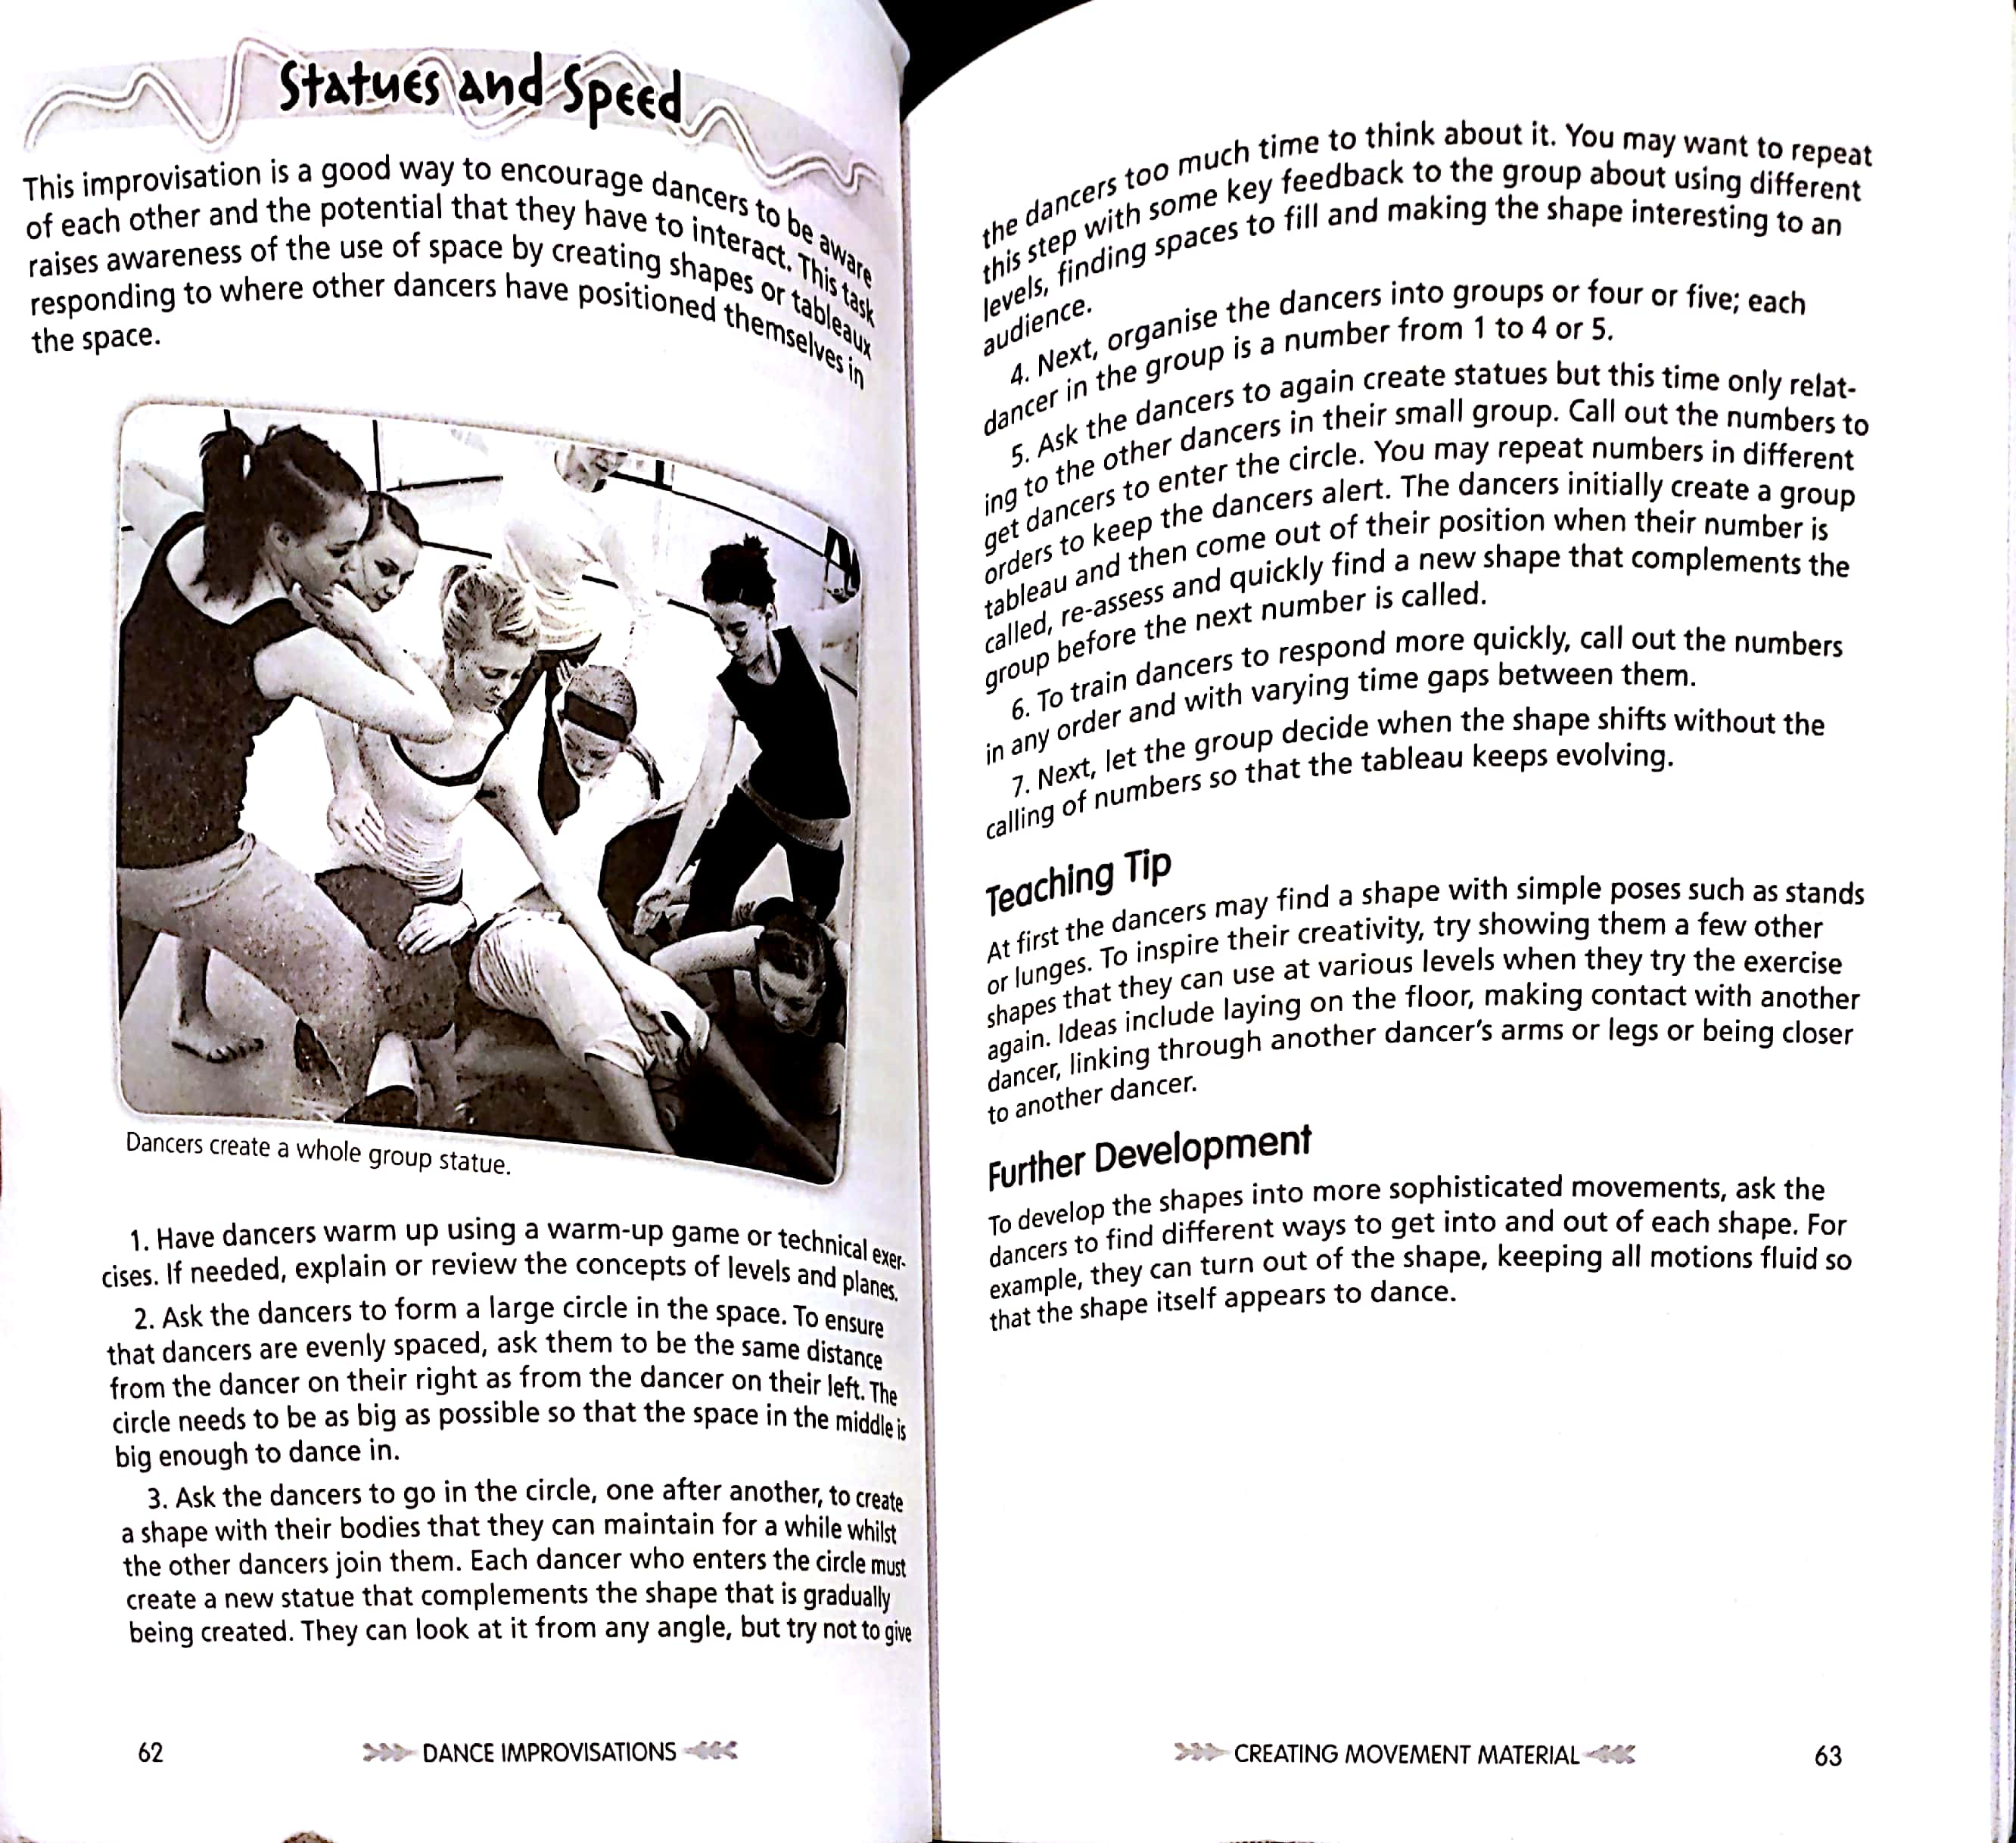

Appendix E
Activity 5 Prompts
Selected dance movements –
A range of movements are selected based on the level of difficulty and suitability.
Ride the pony, Backpack kid dance, Default dance, Fresh, Take the L, Flapper dance, The Robot, Disco fever, Wiggle, Tidy (in case student not able to use legs/ hurt), Hype, Orange justice.
Prompts –
Perform it as quickly as possible.
Perform it as slowly as possible.
Perform it as if the body were heavy.
Perform it as if you needed the toilet.
Perform it as if you were late for a train.
Perform it as if you were sleepy.
Perform it as if they were not happy to be watched.
Perform it as if you are a superhero.
Perform it as if you are a robot.
Perform it as if you have two heavy suitcases.
Perform it as if you were thirsty.
Perform it as if you had long limbs like an octopus.

Appendix F
Activity 6
Protect the Kingdom:
Children are divided into groups of four. Five special spots (marked with different coloured cones, the same coloured sashes given to each team member) around the gym are guarded by four bowling pins placed around it in a circle. They are given one ball. The goal is to knock down all the bowling pins of the opposing teams with the ball.
Rule 1: They cannot run around with the ball in their hand. They have to pass it to a team member closest to the bowling pins to throw or aim at it.
Rule 2: They are only allowed to knock down one bowling pin at a time (they will be placed by the teacher in a way to ensure they all do not fall together).

Conclusion:
How did your team work together? What specifically worked well? What difficulties did you experience?
What role did each person play in the group? How was each person helpful to the end goal?
How did you feel about your level of participation?
What would you do differently if you were given a second chance at this activity?
What is the best part of working on a team?
What is the most difficult part of working in a team?

Appendix G
Activity 8 Worksheet

Step | Body movements | Total counts
1 | 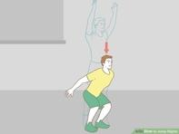 +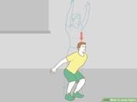 +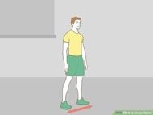 + +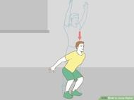  Vertical jump + Vertical jump + Left Side step + Right side step + Vertical jump = | =5
2 | 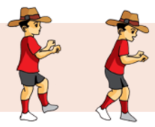++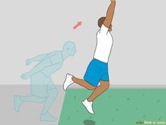+++  Gallop + Gallop + Leap + Gallop + Gallop + Leap = | =6
3 | 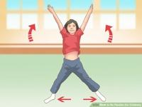++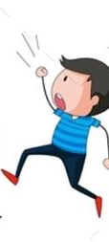++++  Star jump + Star jump + March + Star jump + Star jump + March + Star jump = | =7
4 | Repeat all 3 together: One full rotation of the dance. (draw here if needed) | 18

Appendix H
Final dance performance task
People experience seasons in many ways and there are various representations and organisations of seasons in different parts of Australia and in other parts of the world. Students develop ideas for an invented season and create movement sequences to communicate their ideas. Students need to be familiar with various concepts of seasons prior to undertaking the activities in this phase of the module.
At this final stage, students are reflecting on their dance and the dance of others. Students should be encouraged to consider all ideas and forms of expression when communicating. They:
- brainstorm ideas to invent a new season — for example, an extra season, a birthday season, or invent a season that could exist on another planet,
- create a list describing the aspects of their invented season, and brainstorm movement ideas to represent these aspects — for example, the birthday season might involve celebration of the birthday person through a ritual dance characterised by the use of space, time and energy (movement components), such as circular floor patterns, in a steady rhythm, with strong energy.
Students create a dance sequence choreographed by themselves or with the help of the teacher. Encourage them to experiment with and manipulate their performances by using the components of time, space and energy as they learn how to communicate personal intent and expression in relation to their seasonal theme to an audience.

Appendix I
Activity 9:
Discuss how they used space, time and energy in
their own movement exploration:
– Space — Did my movements cover a lot of space
or did I stay on the spot? Why, why not?
– Time — Did my movements happen over a long
amount of time or did they happen quickly? Why,
why not?
– Energy — Were my movements strong and high
in energy or were they gentle or sustained? Why,
why not?

What will my body do?
How What action will I make?
What space will I use?
What time will I take?
What energy will I create?
What relationships will I use?

Appendix J
Rubric

Task:
Students select dance components (time, effort, space) to create movement sequences that communicate feelings, relationships and narratives.
Criteria: | Student Observations:  The teacher may use:  ● observation  ● student/teacher consultation  ● focused analysis  Recorded in:  ● anecdotal records  ● observation notes  ● video recordings
Criteria: | Proficient | Emergent | Developing
Body:  Aware of self’s body in relation to others in the space, engages in creative movements with partner using body.  Student performance: Uses the body to demonstrate an understanding of symmetry, shapes and angles when performing movement skills, balances or movement sequences. | Understands the concept in depth and is able to independently demonstrate through application. | Basic understanding of the concept and is able to demonstrate through application with the help of scaffolding. | Struggles to understand concept, is not able to apply.
Space:  Student move freely through personal (close) and general (open) space when moving individually, in pairs or in groups, maintaining created shapes.  Teacher Observation: Observe students at play to determine if they are making adequate use of space. Inquire as to how long each team kept the ball away from the other team, suggest reasons why.  Student Performance: Students respond to questions about the importance of space and spreading out in playing games. Evaluate students’ ability to use creative thinking and problem-solving skills in using and maintaining space adequately in game and play situations. Evaluate students’ ability to move right, left, in a zig-zag path as fast as possible. | Understands the concept in depth and is able to independently demonstrate through application. | Basic understanding of the concept and is able to demonstrate through application with the help of scaffolding. | Struggles to understand concept, is not able to apply.
Time:  Acceleration and deceleration of movement in physical activities.  Students perform combinations of movements such as quick changes of direction, speed or levels?  Effort:  Different levels of movement pathways, and use of space and flow in movement sequences | Understands the concept in depth and is able to independently demonstrate through application. | Basic understanding of the concept and is able to demonstrate through application with the help of scaffolding. | Struggles to understand concept, is not able to apply.
Relationships and Wellbeing  Adopt inclusive practices when participating in physical activities.  Modifying physical activities to ensure that everyone is included, such as changing equipment, rules or playing space  Provide positive feedback to peers. | Understands the concept in depth and is able to independently demonstrate through application. | Basic understanding of the concept and is able to demonstrate through application with the help of scaffolding. | Struggles to understand concept, is not able to apply.

APST 1.1- Physical, social and intellectual development and characteristics of students. Warm up activities and tasks selected for explicit instruction of concepts are selected in consideration of students’ developmental needs and requirements. They engage in exciting and meaningful opportunities that allow them to use their developing intellectual capabilities and construct knowledge in a social setting.
APST 4.1 Support participation of learners Throughout the unit, the students would be asked to utilize their strengths to perform movements. There are no mandated movement that all students have to perform; rather, all students can utilize their creativity and innovation to participate meaningfully in the lesson activities. Establish and implement inclusive and positive interactions to engage and support all learners in learning activities.
Valuing Movement: Students apply concepts and skills learnt in, about and through movement to create a dance sequence. Throughout the sequence, they learn to appreciate the value of movement by tracking their feelings before and after sessions.
Strength-based approach

